1. Given the provided data, what are three conclusions we can draw about Kickstarter campaigns?
   * Kickstarter have certain categories that succeed.
   * Most categories do not have enough funding to succeed.
   * A Strategy or campaigns to support projects.
   * Shows a possibility of higher success rate if properly targeted the right market for each projects.

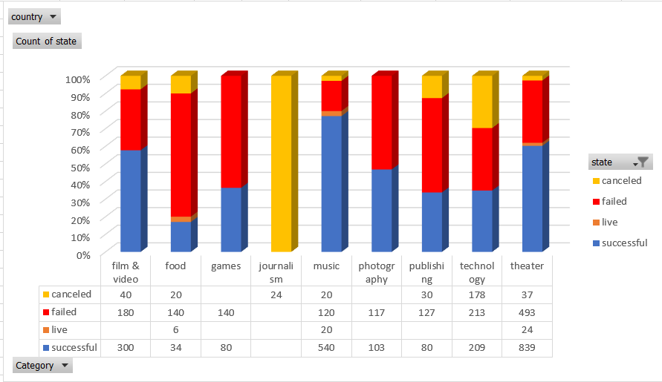

1. What are some limitations of this dataset?

* It would be more specific if we could see the target market.
* Geographical data that will show the success of each project and its market.
* Actual cost for launching a project and maintaining it.
* Causes of failure and cancelation of project.

1. What are some other possible tables and/or graphs that we could create?

* Possible graph of 80/20 showing the causes of projects to fail
* Correlation graph of Genres and ages in the market to see a profitable or to see which project has a bigger chance to be successful.
* Linear regression to predict the success after identifying the correlation of data.